

**Technical Proposal**



QDS/AM/Customer/Project

**Date.**

**QDS Ref.**

**TENDER Ref.**

20 November 2023

**Tender Name**

**Client Name**

**Document Subtitle**

XXX/XXX/0000/000

**Table of Contents**

Document Management & Version Control 3

CONFIDENTIALITY STATEMENT 4

QDS Contact Information 5

Executive Summary 6

RFP Requirements 6

QDS Company Profile 7

Introduction 7

What We Provide 9

Solutions And Services Offered 9

QDS Partner Alliances 11

Proposed Solution 12

Proposed Bill of Quantity 13

Compliances 14

Implementation Approach 15

In-Scope 15

Out Of Scope 15

Assumptions 15

Project Management Methodology 16

PMO Processes 16

Communications Management 16

Risks Management 17

RAID Log 17

Change Management 18

Project Major Variables 18

Project Governance and Oversight 18

Post implementation support and SLA 19

General Description 19

Levels of Support 20

Front-End Support 20

Back-End Support 20

**Response and Resolution Guidelines** 20

**Contact us using the below support Request Procedure.** 21

**QDS Contact Details Outside Working Hours** 21

**Escalation Matrix** 21

Terms and Conditions 22

Datasheets 24

Appendix 25

# Document Management & Version Control

|  |  |
| --- | --- |
| **Document Title:** | <Document Title> Technical Proposal |
| **Proposal Reference #:** | Ref: QDS/AM/Customer/Project |
| **Issued By:** | <<To be filled>> |
| **Issue Date:** | 03/09/2023 |
| **Reviewed By:** | <<To be filled>> |
| **Approved By:** | <<To be filled>> |
| **Status:** | <<To be filled>> |

|  |  |  |  |
| --- | --- | --- | --- |
| **Date** | **Version** | **Author** | **Remarks** |
|  |  |  |  |
|  |  |  |  |

# CONFIDENTIALITY STATEMENT

The recipient of this document agrees that the information provided within this document is to be considered confidential and proprietary to **QDS**. The recipient shall not use confidential information other than for the purposes of its business with QDS, and shall disclose it only to its officers, directors, or employees with a specific need to know. The recipient will not disclose, publish, or otherwise reveal any of the confidential information received from **QDS** to any other party whatsoever except with the specific prior written authorization of **QDS**.

All documents provided by **QDS** are copyrighted and/or protected from any changes or modifications or any other kind of use outside the scope defined between **QDS** and the Recipient.

**QDS** retains all title, ownership and intellectual property rights to the information contained herein, including all supporting documentation. By acceptance of this document, the recipient agrees to be bound by the statement.

**Qatar Datamation Systems Copyright©**

**11/20/23**

QDS Contact Information

**Name Here, Account Manager - Commercial**

|  |  |  |
| --- | --- | --- |
| **Telephone with solid fill** | **Telephone** | +974-XXXX XXXX |
| **Receiver with solid fill** | **Mobile** | +974-XXXX XXXX |
| **Printer with solid fill** | **Fax** | +974-XXXX XXXX |
| Email with solid fill | **E-mail** | [info@qdsnet.com](mailto:info@qdsnet.com) |

# Executive Summary

<<To be filled>>

## RFP Requirements

<To be filled by Presales Consultant / Manager>

# QDS Company Profile

## Introduction

**Qatar Datamation Systems (QDS)** provides a wide range of fully integrated IT Based Solutions that are innovative and customised to any industry. We help Private Enterprises and Government Institutions across Qatar and other parts of the Middle East to fluently adapt to a rapidly changing digital environments. The finest ensemble of Partnerships with International IT corporations and over hundreds of successful projects across various industries, **QDS** is Qatar’s leading company that provides a wide range of technology services.

Our fundamental goal is to customise and provide the most efficient and profitable IT solutions to our customers, to pave their path to success. **QDS** provides result-oriented services that aim at 100% customer satisfaction and beyond. We enhance our customers’ organizational efficiency, productivity, and profitability using the latest technology, analytics, and decades of expertise.

**Since 1983**, we at **Qatar Datamation Systems** make it our priority to provide premium quality of products, services and solutions with a purpose driven growth mindset. We clearly understand that digital transformation goes beyond technology implementation; it requires a holistic approach that encompasses people, processes, and culture. By conducting in-depth assessments, we identify areas of improvement and craft a roadmap for successful digital transformation.

We strive to exceed our customers’ expectations by keeping them at the heart of our business. We strive to work closely with clients to understand their business goals and challenges and provide them an edge with the speed of technology and innovation.

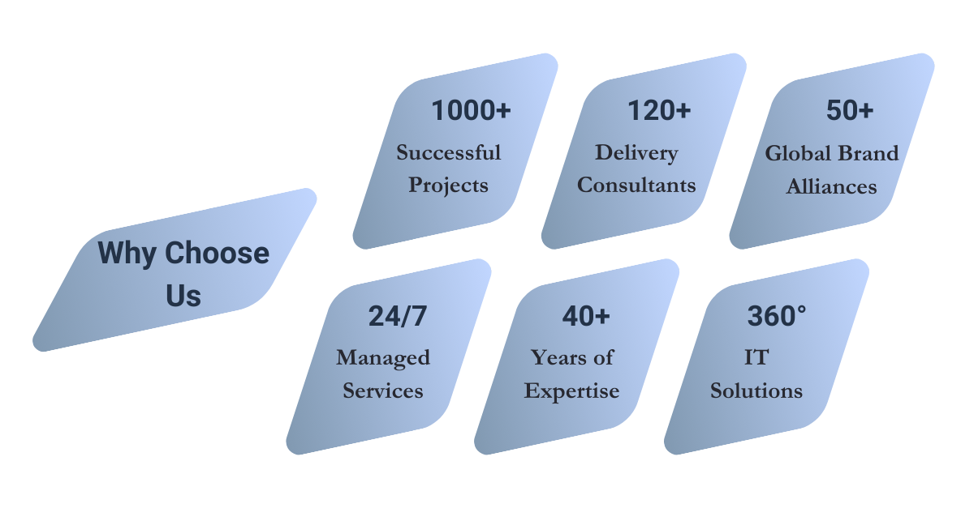

**Redefining Excellence Since 1983**

|  |  |
| --- | --- |
|  | **Our Vision**  To be recognized and valued as the leading and most trusted systems integrator in Qatar. |
|  | **Our Mission**  Committing to deliver highly effective business outcomes and results for our clients through their IT endeavours and projects with highest standards of implementation, Integration and support services and by capitalizing on our expertise in technology solutions, consultancy, and effective project management. |

|  |  |
| --- | --- |
| **Our Values** | |
| Our values are defined by **#QDSTEAM** | |
|  | **UALITY**  Giving the Best and Unmatched Results for all round satisfaction will shape the future of the company and the market. |
|  | **ETERMINATION**  Our strong determination to success will never let obstacles overtake us. We show pride, enthusiasm, and dedication in everything that we do. We are committed to selling and delivering high quality products, services, and solutions. |
|  | **ERVICE EXELLENCE**  Giving the best-in-class service and achieving excellence each passing day. Taking full ownership of the company and customer success. |
|  | **EAM WORK**  We promote, respect and support a diverse, yet unified team. We are loyal to one another and work together to meet our common goals. We care for each other both personally and professionally. We celebrate success of individuals and teams too. |
|  | **MPOWERMENT**  Empowering our talented employees to take the initiative, give the best and take the right action. |
|  | **CCOUNTABILITY**  We accept our individual and team responsibilities, and we meet our commitments. We take responsibility for our performance in all our decisions and actions that will reflect positively our relationship with customers and employees. |
|  | **AKING A DIFFERENCE**  We go above and beyond for our clients whenever possible. We believe that excellence is no option, it is our choice. We believe that our integrity, passion and excellence must be synchronized to make the difference in our clients’ business and our employees personal and professional lives. |

## What We Provide

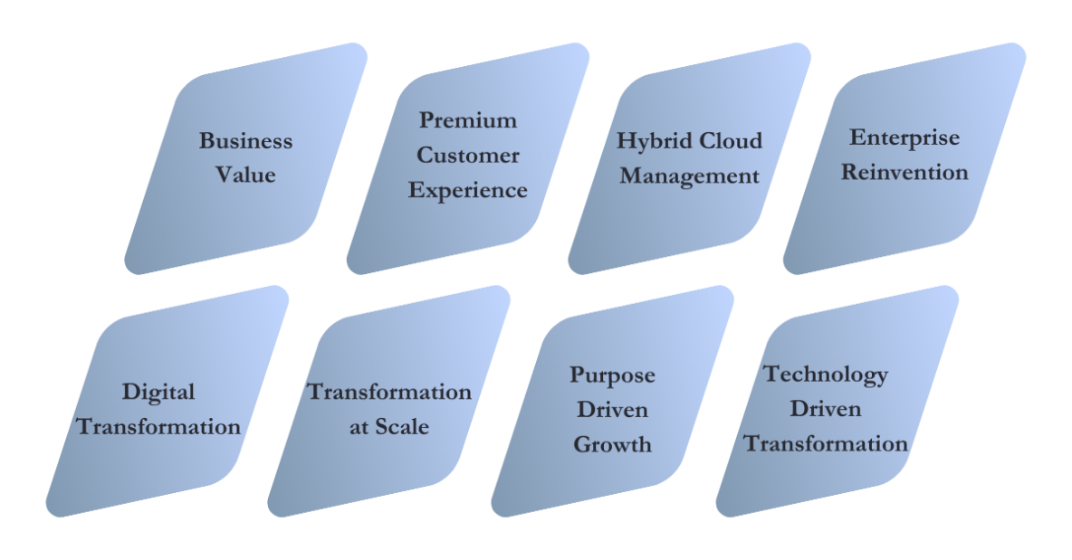

## Solutions And Services Offered

|  |  |  |
| --- | --- | --- |
|  | * **Microsoft Solutions:** * Modern Workplace Solutions * Enterprise Mobility, Security and Compliance * Azure Infrastructure Solutions * Application Modernization * Dynamics ERP/ CRM - Power Apps * Data Management, Analytics and AI * Teams Collaboration Solutions * AVS * ARO * Azure Netapp Solutions * Devops and Microservices * Sentinel Solutions * SAP Services * Surface * Resources Augmentation | * **Emerging Technologies Solutions:** * Virtual Desktop and Apps Virtualization * Digital Experience Solutions * App / Mobile App Development * Document Management Systems and Archiving * Workflow and RPA * DR Automation * Managed Services * OT / IOT Solutions |
|  | * **DEVELOP** * DevOps Solutions * Application Modernization * Functional Testing * Application Load Testing * Container Platforms (Kubernetes) * **SECURE** * Application Security * Container Security * Vulnerability Management * Network Detection Response * SIEM Solution * Log Management * Mobile Device Management | * **OPERATE** * Enterprise Service Management * Asset Management (IT and Fixed Assets) * Software Compliance * Endpoint Management * Zero Touch Patching * Application Performance Monitoring * Network Monitoring * Infrastructure Monitoring * **TRANSFORM** * Hybrid Cloud Management * Digitization and Document Management * Business Process Automation * Network Automation * Cost Optimization * API Management * AI and Data Analytics |
|  | * **Server** **Solutions**: * Rack Mount Servers * Standalone Tower Servers * Modular Infrastructure / Blade Servers * Composable Infrastructure * HPC * **Storage Solutions**: * SAN Storage * NAS System * Unified Storage * Scale out NAS / Object Storage * Backup/Tape Storage * **Commercial End User Personas**: * Laptops * Desktops * All-in-Ones * Workstations * Thin client * Rugged Laptops * **Data Center Facilities**: * Rack Infrastructure * UPS & Power Infrastructure * Modular Datacenter | * **Virtualization**: * Hyperconverged Infrastructure * SDDC Solutions * Server virtualization * Storage virtualization * VDI Solutions * Hybrid Cloud Solutions * Business Continuity * Metro Clusters (Active/Active DC) * Disaster Recovery Solutions (Synchronous/Asynchronous) * Data Protection Solutions * Archiving Solutions * Cyber Recovery Solutions * Cloud Backup/Cloud DR Solutions * Ransomware Protection * **Business Models**: * On-premises Infrastructure * Finance/Leasing Solutions * Pay per use On-premises solutions. * Cloud Services |
|  | * Design * Consulting * Audit * Training |  |
|  | * Application Modernization * Application Monitoring * ITSM * CMS * Private Cloud * Data Centre Automation * Data Centre Monitoring |  |
|  | * **NETWORK SOLUTIONS:** * Access Network * Wireless Network * SDN, SDWAN * Network Access Control * Network Tapping * DNS-DHCP-IPAM * **SECURITY SOLUTIONS:** * Zero Trust Security * Secure Access Service Edge (SASE) * Governance Risk & Compliance * DNS Firewalls * Endpoint protection * Secure Web Gateway * Next Generation Firewall * Software Defined Networks * Email Security | * Data Loss Prevention * Data Classification * Application Delivery & Security * Data Encryption * Key Management * Database security * Vulnerability Assessment & (Penetration testing (VA-PT) * Advanced Threat Protection * Security Awareness Solution * Identity & Access Management * Multi Factor authentication * Privileged Access Management * Digital Risk Management * Cloud security * Business Continuity Solutions * OT/ICS Security |
|  | * Managed IT Infrastructure * Managed Cloud Infrastructure * Managed Applications * Managed Database * Managed EUC (End User Computing) * Managed DR and BC * Managed SOC * Managed NOC Monitoring |  |
|  | * Onsite support * Remote Support * 24/7 technical support * Software updates & releases as per vendor recommendations * L1 & L2 Technical Support * Unlimited requests for SLA customers * Periodic Health checks and Remediation * RMA management |  |

## QDS Partner Alliances

As a leading system integrator, QDS collaborates with a diverse range of vendors to offer a comprehensive solution portfolio, as outlined in our company profile. This extensive technical versatility, combined with our certified expertise and extensive experience, positions us uniquely to deliver Qatar Foundation a competitive edge in multifaceted solution integrations. Below is a snapshot of our vendor partnerships, with a more detailed list available upon request.

|  |  |  |
| --- | --- | --- |
|  |  |  |
| Vendor Name | **Partnership level** | **Logo** |
| DELL | * Titanium Partner |  |
| HPE | * Platinum Partner |  |
| VEEAM | * Gold Partner |  |
| MICROSOFT | * Microsoft Partner of the Year |  |
| THALES | * Platinum Authorized Partner |  |
| SOPHOS | * Enterprise Partner of the Year |  |
| COMMVAULT | * Partner of the Year |  |

# Proposed Solution

* Solution Summary
* High Level Design (including Visio diagram)
* Dependencies (Hardware and Software Requirements)
  + Hardware Requirements(Minimum)
    - TestComplete:
      * Microsoft Windows 7 with Service Pack 1.
      * Intel Core 2 Duo  2 GHz or higher.
      * 2 GB of RAM.
      * 4 GB of free space on the system disk.
      * 2 GB of free disk space for installation, plus extra space for temporary files during test runs.
      * 1024×768 or higher display resolution
    - ReadyAPI:
      * Intel Core i3 (3rd generation or later).
      * 8 GB of RAM or more. At least 1 GB of free RAM
      * 600 MB of free disk space for installation.
      * 1280 × 1024 display (widescreen monitors are recommended).
    - Zephyr Enterprise:
      * Windows Server 2008
      * Windows 7 Enterprise
      * Quad-core CPU Intel Pentium or AMD Opteron (2Ghz or higher)
      * 8GB RAM
      * 5GB OF Free disk space (250GB-1TB recommended for large enterprise installations)
      * Database Embedded MySQL and remote MySQL only.
  + Software Requirements
    - TestComplete – .exe to run & install, No dependencies.
    - ReadyAPI - .exe to run and install, No dependencies.
    - Zephyr Enterprise - .exe to run and install, Dependency – Java latest version to be installed.

# Proposed Bill of Quantity

|  |  |  |
| --- | --- | --- |
| Part Number | Description | QTY |
| <<To be filled>> |  |  |
| <<To be filled>> |  |  |
| <<To be filled>> |  |  |
| <<To be filled>> |  |  |
| <<To be filled>> |  |  |
| <<To be filled>> |  |  |
| <<To be filled>> |  |  |

# Compliances

|  |  |  |  |
| --- | --- | --- | --- |
| **#** | **Functionality** | **Compliance (FC/PC/NC)** | **Comments** |
| **Test Management Tool** | | | |
| 1 | The tool to be highly customizable and highly intuitive user interface. | FC |  |
| 2 | Supports DevOps Model | FC |  |
| 3 | Allow integration with other applications like Azure DevOps, Automation tool, performance tool, code repository, CI/CD tools. | FC |  |
| 4 | Support different Test design approach | FC |  |
| 5 | Ability to migrate existing test assets to the new Test Management tool | FC |  |
| 6 | Ability to easily organize test assets across Applications/projects/releases. | FC |  |
| 7 | Ability to reuse test assets across releases and projects | FC |  |
| 8 | Re-execute same test cases across different platforms (Browsers/Mobile platforms) | FC |  |
| 9 | Highly Customizable defect management process | FC |  |
| 10 | Ability to raise defects through other thirdparty applications. | FC |  |
| 11 | Test Management tool must provide with customized and standardized reports. | FC |  |
| 12 | Configurable dashboards with ability to send emails periodically/ based on some triggers | FC |  |
| **Automation Tool** | | | |
| 1 | Tool to support web, mobile, API, hybrid, and enterprise apps. | FC |  |
| 2 | Support automation at interface layer, service layer, and database layer | FC |  |
| 3 | Support script less automation. | FC |  |
| 4 | Ability to support different browsers | FC |  |
| (Chrome, Firefox, Safari, IE, and Edge) |
|  |
| 5 | Should support all major software application including Oracle, Salesforce, embedded frameworks, headless browsers. | FC |  |
|  |
| 6 | Supports parallel execution | FC |  |
|  |
| 7 | Allow integration with other applications like Azure DevOps, Test Management tool, performance tool, code repository, CI/CD tools. | FC |  |
|  |
| 8 | Allow integration with cloud based mobile testing platforms. | FC |  |
|  |
| 9 | Ability to run web and mobile tests from Docker containers. | FC |  |
| 10 | Support parallel execution of test cases in multiple mobile devices | FC |  |
| 11 | Tool must provide with customized and standardized reports. | FC |  |
| **Performance Tool** | | |  |
| 1 | Performance Test tool should support a variety of applications including mobile, .NET, Java, SOAP, Flex, HTML 5, ERP, legacy, GWT, Silverlight, Ajax, and Citrix. But not limited to this list | FC |  |
| 2 | Support root cause analytics. | FC |  |
| 3 | Ability to provide consolidated reports with response time, CPU utilization and memory utilization during the test runs. | FC |  |
|  |
| 4 | Performance tool must provide with customized and standardized reports. | FC |  |
| 5 | Easy monitoring through dashboards. | FC |  |
| 6 | Detailed reports to show the response time for all the downstream applications. | FC |  |
| 7 | Allow customized bulk communication through E-mail and SMS. | FC |  |
| 8 | Accurate Scalability Expense Prediction | FC |  |
| Supports cloud testing |
|  |
| 9 | Allow integration with other applications like Azure DevOps, Test management tool, code repository, CI/CD tools. | FC |  |
| 10 | Ability to simulate Realtime bandwidth and connection settings. | FC |  |
| 11 | Support Performance testing on load balancer. | FC |  |

Implementation Approach

<State what is in scope, out of scope, for this project. Also state the exclusions in the project>

<To be filled by Project Team>

## In-Scope

<<To be filled>>

Installation, Configuration and Implementation of Quoted solution based on BOQ mentioned in Commercial Proposal and tender document submitted.

## Out Of Scope

<<To be filled>>

Installation, Configuration, Customization, Migration of Any Third-Party Software/Application, Networking, Security Hardware which are not Included in our proposal, Structured Cabling, Electrical, Power, Site Preparation.

## Assumptions

<<To be filled>>

# ASSUMPTIONS, DEPENDENCIES & PRE-REQUISITES

|  |  |
| --- | --- |
| **Phases** | **Key Assumptions** |
| **Scoping & Planning, Test Preparation** | All upstream project planning, design, build activities will happen as per agreed project schedule with no or minimal impact to testing |
| Xilligence will have required access to the premises, necessary system privileges, tools, and resources in line with client policy. |
| No software design or development activities will be undertaken by Xilligence. |
| Xilligence understands that client shall be sharing the existing repository of Test Cases during the project for test automation. |
| Xilligence will not be liable for any delays caused by third party service providers |
| Details walkthrough of the application functionality shall be provided by the client for automation scripting. |
| It is assumed that all the required application specific document will be shared with Xilligence consultants prior to the start of test preparation phase |
| **Hardware** | **Computers:** Desktop/ Laptop – Applicable windows versions  **Mobiles:** IOS and Android. (Required for testing)  **Browsers:** Should be made available as per the requirement of CLIENT |

|  |  |
| --- | --- |
| Phases | Key Dependencies |
| Scoping & Planning, Test Preparation | CLIENT shall assign a Project manager or SPoC (Single point of contact) for the duration of the project and till the work is completed and handed over to the CLIENT, all correspondence relating to this project shall be communicated to CLIENT through the assigned SPoC |
| Access to system requirements will be provided where possible in the form of user manual, requirement documents & screenshots. Access to key individuals within CLIENT Team with relevant product knowledge should be provided |
| Test Execution (UAT and Regression) | Availability of test environments |
| IT support is required for the test data preparation for testing cycles based on the test data requirements identified by Xilligence. |
| Xilligence will liaise with departments in identifying the nominees for this Test Automation requirement. |
| Hardware specs to be made available on time during test execution |
| CLIENT will ensure the support for various application back-end systems Mobile applications, middleware interface and other related systems. |
| Devices required for testing should be provided by CLIENT |

# Project Management Methodology

QDS Project Management Office (PMO) is applying the below Project Management methodology to manage both the infrastructure, and Applications Development projects in a smooth, and a professional way to accomplish a satisfactory project delivery. The below processes are subjected to a slight tailoring based on <<Customer Name>> organization, and how both parties are aligning to manage the project.

## PMO Processes

QDS is following the standard PMI project management life cycle, and accordingly all the Standards related to the scope & schedule management, issues management, communications & stakeholders management and risk management are performed throughout the project lift cycle. 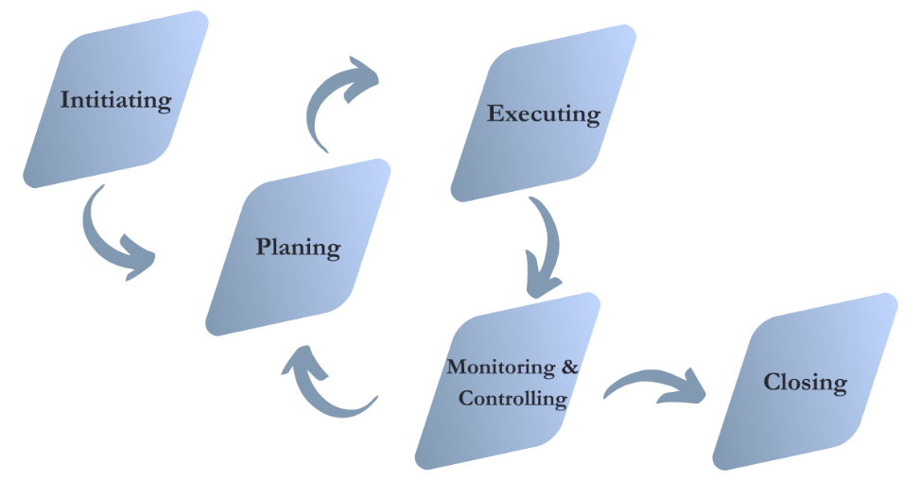

This methodology ensures quality of technology and business-process deployment throughout the project life cycle. Moreover, this will ensure to provide the required support information and tools for implementation, helping organizations determine to the correct system data structures to meet their usage, security, reporting, and other functional requirements.

The non-functional aspects of the implementation, related to management of project activities, will be catered to through identified key processes to achieve the defined objectives of the implementation. These key processes will involve: Scope & Schedule Management

* Scope & Schedule Management includes the processes required to ensure that project Scope Statement is clearly developed and aligned between all stakeholders, along with the timely completion of the project.
* The Project Manager will be responsible for the identification of phases, sub-phases, activities, and tasks within the scope of the project. Schedule work plans will be maintained throughout the life of the project, with comparison of actual project progress to plan on defined intervals. Schedule information will be communicated to <<Customer Name>> with issues and risks, with prioritization through the above-described Communications framework.

### Communications Management

Project Communications Management includes the processes required to ensure the timely and appropriate generation, collection, dissemination, storage, and ultimate disposition of project information.

For managing the scope of project documentation, a Project Communications channel will be established to clearly define the users on information flow, the frequency of information flow and project meetings. In addition, a project central repository will be established which facilitates the storage, review and retrieval of all documents related to the project. Key elements of communications planning will include regular, timely and accurate information regarding the project status, progress, activities, issues, risks, staffing, changes, and completion.

### Risks Management

Project Risk Management includes the processes concerned with identifying, analyzing, planning, and responding to project risk.

A proactive risk management approach will be established, in which the project team would have a visible process for managing risks in a measurable and repeatable manner. With such a proactive risk management process in place, the team will assess risks continuously and use this information to make decisions in all phases of the project.

### RAID Log

RAID stands for Risks, Assumptions, Issues and Dependencies.

The above-mentioned attributes are tracked and updated during the project to gain better control on the delivery of the project. The team provides input to the Project Manager as and when a risk or issue arises and is captured in the document. The RAID Log is tracked and updated as and when an event occurs in the respective category.

* **Risk Register**

|  |  |  |  |  |  |  |  |  |
| --- | --- | --- | --- | --- | --- | --- | --- | --- |
| **Risk ID** | **Risk Name** | **Risk Description** | **Impact Description** | **Probability** | **Impact** | **Risk Response** | **Owner** | **Status** |

* **Action Log**

|  |  |  |  |  |  |  |
| --- | --- | --- | --- | --- | --- | --- |
| **Action ID** | **Action Description** | **Actions Taken** | **Date Opened** | **Status** | **Owner** | **Date Closed** |

* **Issue Log**

|  |  |  |  |  |  |  |  |
| --- | --- | --- | --- | --- | --- | --- | --- |
| **Issue ID** | **Issue Description** | **Originator** | **Date Open** | **Impact** | **Notes / Updates** | **Owner** | **Status** |

* **Dependency**

|  |  |  |  |  |  |  |
| --- | --- | --- | --- | --- | --- | --- |
| **Dependency ID** | **Dependency Description** | **Impact** | **Result** | **Date Taken** | **Owner** | **Status** |

### Change Management

Change Management is mainly concerned with all the new/updated requirements which have a direct or indirect impact on project timeline or cost.

A Change Control Board (CCB) will be established, functioning as the decision authority for accepting or rejecting changes to the baseline configuration. A thorough assessment of every change is conducted, and accordingly a Go / No-Go decision will be taken

## Project Major Variables

The variables in any project are resources (including QDS and <<Customer Name>> resources), Scope (including features, functionality, the Product, and its quality), and Schedule (or time). As the team develops a solution, it will inevitably have to make tradeoffs among these project variables. The key to project success is finding the right balance among resources, schedule, and features.

The major project variables can be viewed as having a triangular relationship. After the team has established the triangle, any change to one of its variables (or sides of the triangle) requires a correction to at least one of the other variables to maintain project balance.

## Project Governance and Oversight

It is important to establish a clear, an agreed-upon governance structure from the outset. In the Project environment communication, collaboration and decision-making becomes even more challenging and therefore the governance and management structure must be established early, committed to, and fully supported throughout to help the Project stay on track and ensure a successful partnership. An important success factor throughout a Project is the common understanding, agreement, enforcement and respect of roles, and responsibilities. Strong working partnerships among the departments and other key stakeholders must be forged early and nurtured and sustained throughout the life of the Project.

The governance of this Project is by the Executive Steering Committee, Project Management Office, Project Managers, and supporting committees. Escalation, if needed, is to the Project Sponsor and the Executive Steering Committee.

The final structure of the above committees is determined between <<Customer Name>> and QDS Project Managers at the project kickoff meeting along with the project planning meetings.

# Post implementation support and SLA

<<To be filled>>

## General Description

QDS support will be available via email, telephone, or cell number, **08:00 Hrs** to **18:00 Hrs** from **Sunday** to **Thursday**, with individuals sufficiently skilled to assist in problem resolution, in addition Resources will be available on **Friday** or **Saturday** if required, subject to the availability of resource and priority level, described in this document. If necessary, schedule an on-site visit to <<Customer>> to provide support. QDS will provide the service free of charge and the need for on-site support will be determined on a case-by-case basis.

* To enable **QDS** to support you better, we are streamlining our call logging system hence we request you to kindly use the following procedures to log requests.

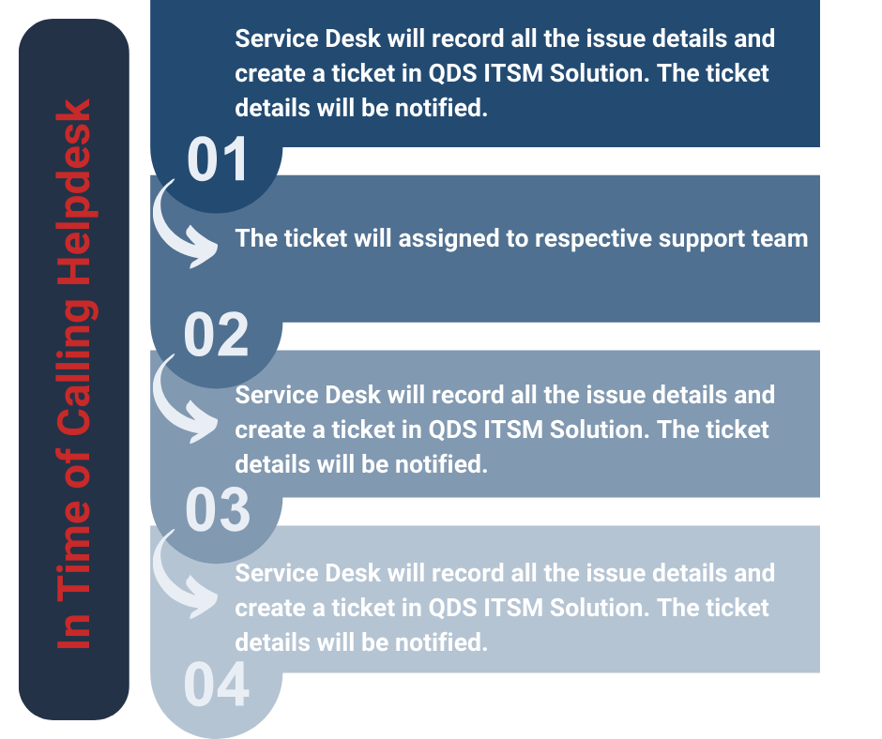

## Levels of Support

<<Customer Name>> will provide Front-end support to their users and customer Support and QDS will provide Back-End Support on an as-required basis.

* QDS will adhere below response and resolution times:

|  |  |  |  |  |
| --- | --- | --- | --- | --- |
|  | **Priority (P1)** | **Priority (P2)** | **Priority (P3)** | **Priority (P4)** |
| Support Window | 24x7 | 24x7 | 24x7 | 24x7 |
| Response Time Target | Within 15 minutes | Within 1 hour | Within 4 hours | Within 6 hours |
| Resolution Time Target | Within 2 hours | Within 4 hours | Within 8 hours | Within 24 hours |

### Front-End Support

QDS will provide first-end Technical Support to <<Customer Name>> application users. Such support includes call receipt, call screening, incident reporting and tracking, and if applicable, the distribution of any replacement media, minor updates, or maintenance releases.

### Back-End Support

Back-end Support includes all efforts required to correct the issue with application when such work is outside the scope of Front-end Support. This work may include, but is not limited to.

(a) Identifying defective Software source code and general Software shortcomings.

(b) Providing corrections, workarounds, Fixes and/or Software Updates to correct Software errors.

<<Customer Name>> will use reasonable efforts to supply QDS with sufficient information to enable QDS to duplicate or identify the Software error. QDS will comply with the following guidelines (“Guidelines”) when involved in problem resolution. Time measurement begins when QDS is first contacted by<<Customer Name>>.

### **Response and Resolution Guidelines**

|  |  |  |  |
| --- | --- | --- | --- |
| **Severity Level** | **Description** | **Max Response Time** | **Issue Identification & Resolution start Max Time** |
| **(A)**  **Submission via Phone** | Critical business impact,  CUSTOMERA is complete.  loss of a core business  Process. | <<Edit Please>> | <<Edit Please>> |
| **(B)**  **Submission via phone or email** | Moderate business impact, CUSTOMERA’s business has moderate loss or degradation of service but work can reasonably Continue. | <<Edit Please>> | <<Edit Please>> |
| **(C)**  **Submission via phone or email** | Minimum business impact, CUSTOMERA’s business is substantially functioning with minor or no Impediments of services. | <<Edit Please>> | <<Edit Please>> |

### **Contact us using the below support Request Procedure.**

|  |  |
| --- | --- |
|  | |
| During Working Hours  **08:00 Hrs To 18:00 Hrs** | Service desk  +974 6687 6233  **Ext.** 151;166 |
| **24** Hour x **7** Days  (Including holidays) | Hotline  +974 6687 6233 |
| **Email** | [helpdesk@qdsnet.com](mailto:helpdesk@qdsnet.com)  [helpdesk2@qdsnet.com](mailto:helpdesk2@qdsnet.com) |
| **Online Logging Portal**  (SLA customers will be provided access upon request) | <http://sd.qdsnet.com:8080/portal>  <https://servicedesk.qdsmsp.com/HEAT> |

### **QDS Contact Details Outside Working Hours**

|  |  |  |  |  |  |  |
| --- | --- | --- | --- | --- | --- | --- |
| **Country** | **Company** | **Position** | **Name** | **Email** | **Local contact** | **Mobile Num.** |
| **Qatar** | **QDS** | Highest Level (GM) | Mr. Mohammad Alam | mohammada@qdsnet.com | +974 4443 9900 | +974 5556 0659 |
| **Qatar** | **QDS** |  |  |  | +974 4443 9900  **Ext.** |  |
| **Qatar** | **QDS** |  |  |  | +974 4443 9900  **Ext.** |  |
| **Qatar** | **QDS** |  |  |  | +974 4443 9900  **Ext.** |  |
| **Qatar** | **QDS** |  |  |  | +974 4443 9900  **Ext.** |  |
| **Qatar** | **QDS** |  |  |  | +974 4443 9900  **Ext.** |  |

### **Escalation Matrix**

|  |  |  |  |
| --- | --- | --- | --- |
| **Description** | **Operational Hours** | **Contact** | **Escalation to** |
| **Level 1** | Sunday To Thursday  **08:00** Hrs To **18:00** Hrs |  |  |
| **Level 2** | Sunday To Thursday  **08:00** Hrs To **18:00** Hrs |  |  |
| **Level 3** | Sunday To Thursday  **08:00** Hrs To **18:00** Hrs |  |  |
| **Level 4** | Sunday To Thursday  **08:00** Hrs To **18:00** Hrs | General Manager | Mr. Mohammad Alam  **Mobile:** +974 5556 0659  **Office:** +974 4443 9900  **Email:** alam@qdsnet.com |

# Terms and Conditions

|  |  |
| --- | --- |
| **Professional**  **Services** | **In Scope** –Above Quote Includes Installation, Configuration and Implementation of Quoted solution based on BOQ mentioned in our Commercial Proposal Submitted & tender document |
| **Out of Scope** - Installation, Configuration, Customization, Migration of Any Third-Party Software/Application, Networking, Security Hardware which are not Included in our proposal, Structured Cabling, Electrical, Power, Site Preparation. |
| **Payment** | <<Edit Please>> |
| **Delivery** | <<Edit Please>> |
| **Support** | <<Edit Please>> |
| **Warranty and**  **Support Start**  **Date** | **Hardware** – Starts from the date of Hardware is shipped from vendor factory/Delivery.  **Software/License** - Starts from the date of License is generated/activated from vendor. |
| **Prices** | * Inclusive of Custom Duty, Freight, and Logistics. * Tax applicable if available. * All options quoted are discounted prices from Vendor and subject to current.   Proposal and deal only. Any changes further shall reflect the commercial. |
| **Force Majeure** | Standard force majeure clause will apply |
| **Assistance &**  **Responsibilities** | * Customer should provide access to all places where the hardware will be Installed. * Customers should also provide electrical supplies as required by the technicians. * Customer will take complete responsibility of any major civil works, Cabling, Electrical, Power, Application and Database Installation require. * Customer responsibility to arrange for the required visa for outside training |
| **Validity** | This proposal will be valid for a period of <<Number>> **Days** from the date of the quotation and thereafter subject to our confirmation in writing. |
| **Order Placement** | Order should be placed on: |
| Qatar Datamation Systems |

# Datasheets

<<Edit Please>>

# Appendix

<<Edit Please>>